Workspace Demo:

In Power BI Service,

1. Create a new workspace 🡪 Needs to be Power BI Pro user. Click on **Try Pro for free** button for 60 days trial, if you are not a Power BI Pro user.
2. Login your Power BI Service account
3. Again, Create a new workspace 🡪 Name 🡪 **WS1**

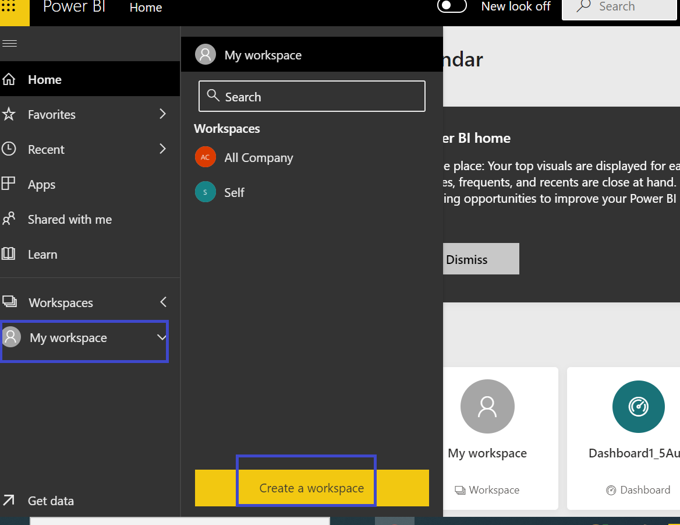

**Note 🡪  The name of workspace would be the name that others will see when joined to this workspace**.

1. Create a report **Sales_Report_2020** based on Sales_Data.xlsx file in **Power BI Desktop**. Have a bar chart of Colors and Cost. and **publish it in the newly created WS1 Workspace** instead of the default **My Workspace** a shown next.

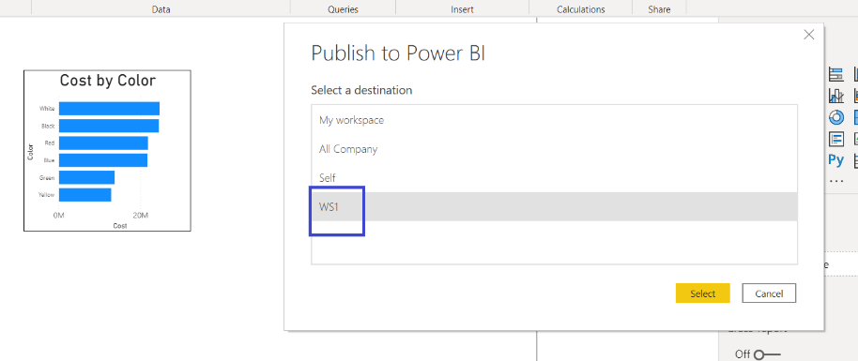

1. Create another report **Employees_2020** based on the Employee source file in Power Bi Desktop. Create a column chart of deptno and salary in it. *Ensure that for deptno field you have selected Don’t Summarize option.*

Create a Column chart of Deptno by Salary and **publish this report also in WS1** workspace as shown next.

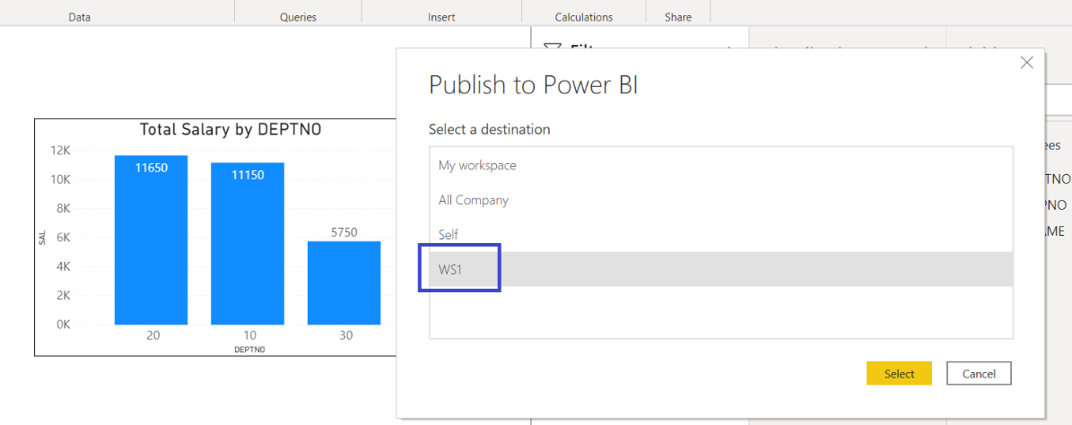

1. In Power BI Service, in WS1 workspace create a Dashboard named **All Summaries** and pin both visuals of the above 2 reports in it.

So far, we have the following things in the newly created workspace WS1:

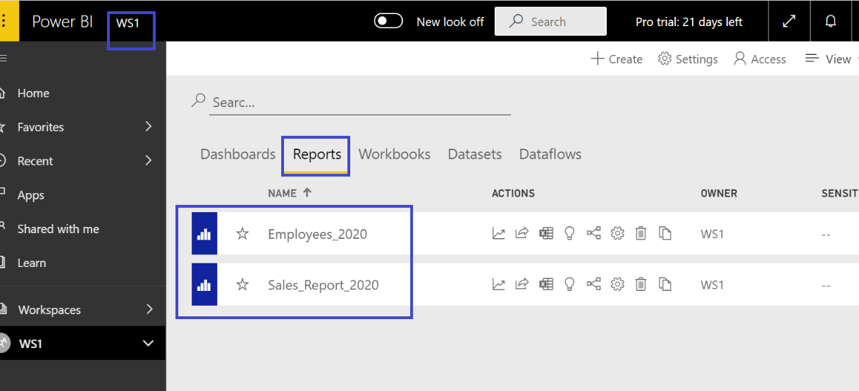

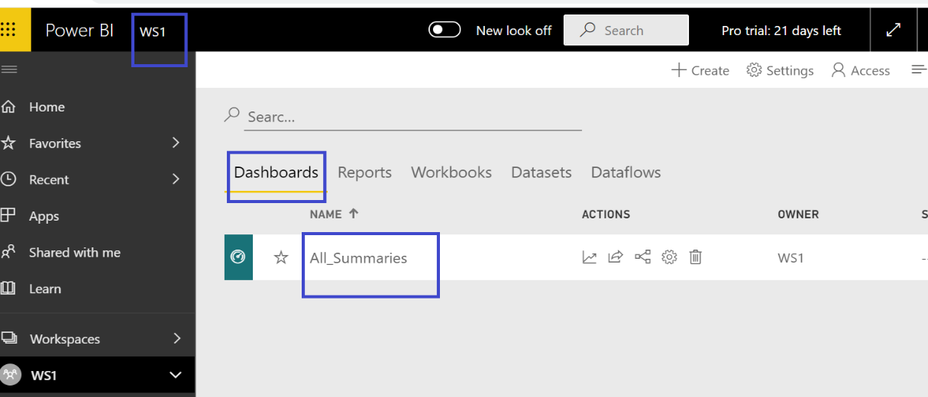

1. Click on **Publish app. This is applicable actually for the End Users, so that they can see all the reports and dashboards of that workspace.**

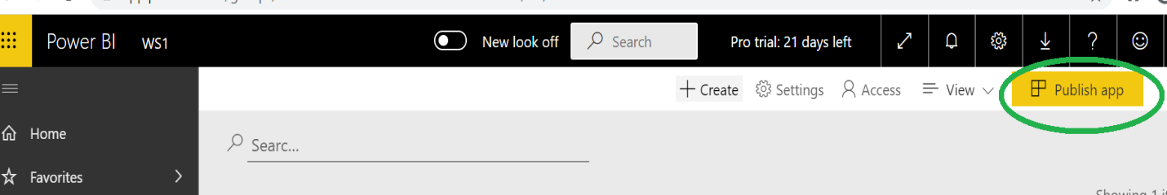

1. **\*\*\* Permissions to be given to user Martin (considered as an End User)** as per below step:

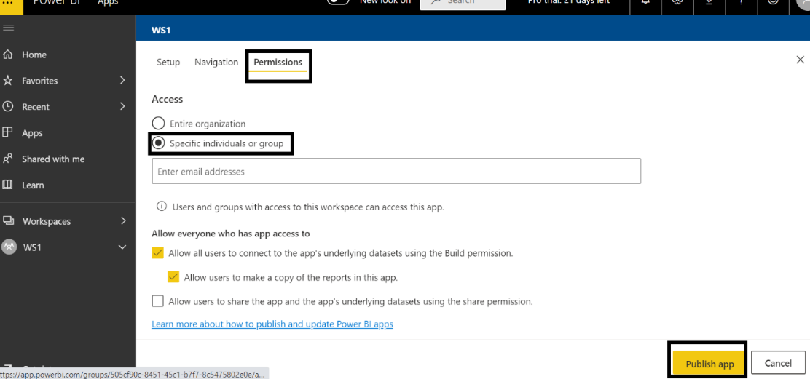

Type Martin or the valid email id of Martin as shown next:

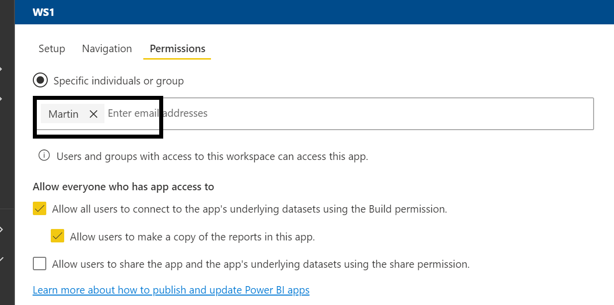

In the **Descriptions** property of **Setup** tab mention:

**All Reports and dashboards can be seen by Martin now** as shown next-🡪

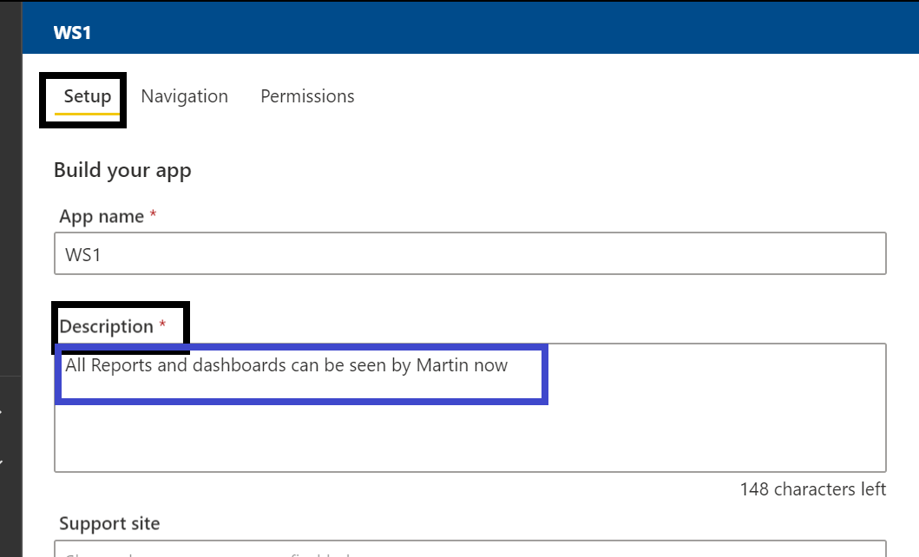

1. Click on the **Publish app** button which is right hand side below.

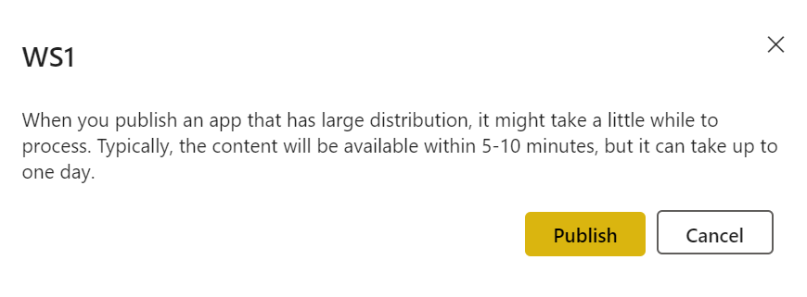

Click on the **Publish** button finally!!!

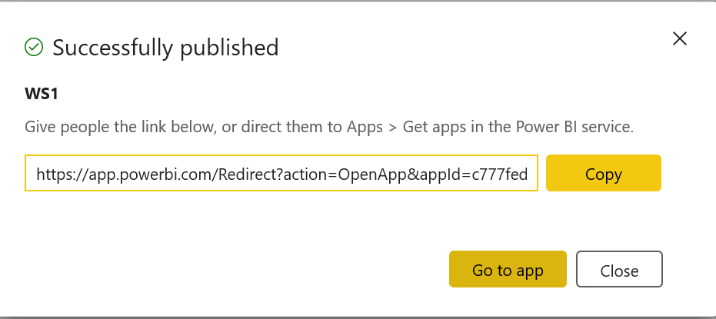

1. Sign out from Power BI Service

****When you publish a workspace as an app, separate access is granted to users. In our case to Martin the workspace is accessible.

1. Martin logins to Power BI Service.
2. ***************In his **Home Page** itself, down the icon of WS1 comes!!!

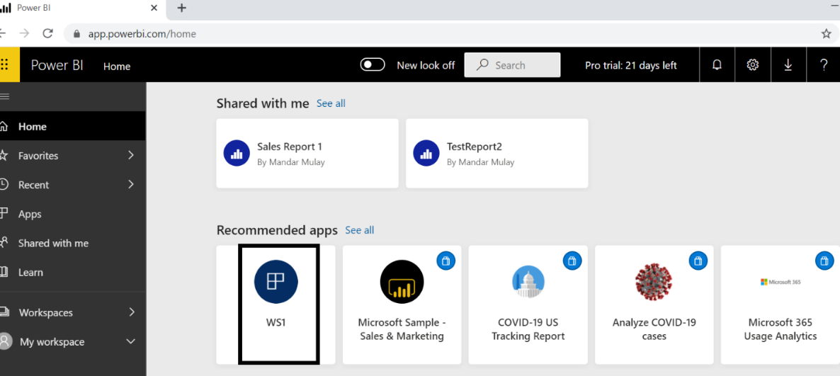

1. Click on that icon **WS1**

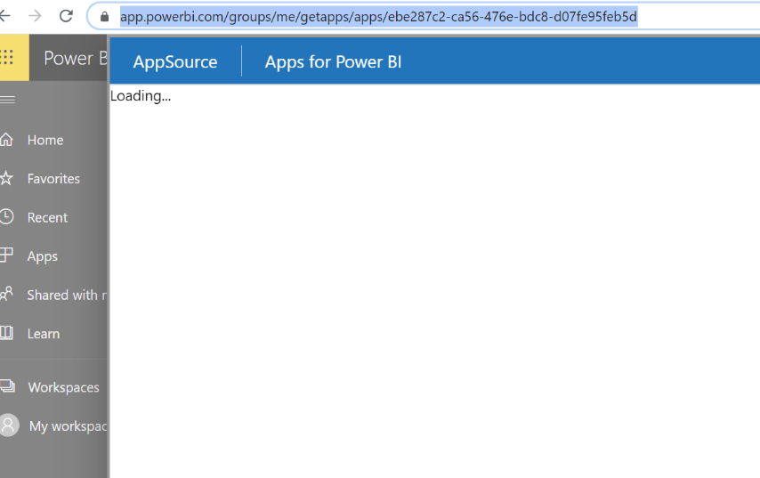

1. If Martin is also not a Pro user then **Try Pro for free**

*Note 🡪 The above Loading step can take some time…….*

1. Click on **GET IT NOW** button from the below step:

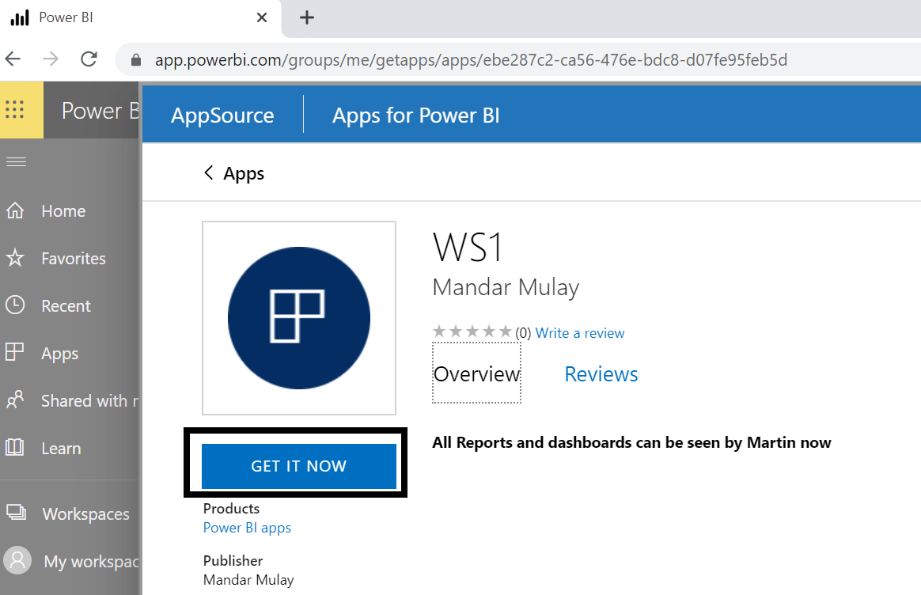

1. **WS1** workspace gets added in Martin’s **Apps** section as shown next.

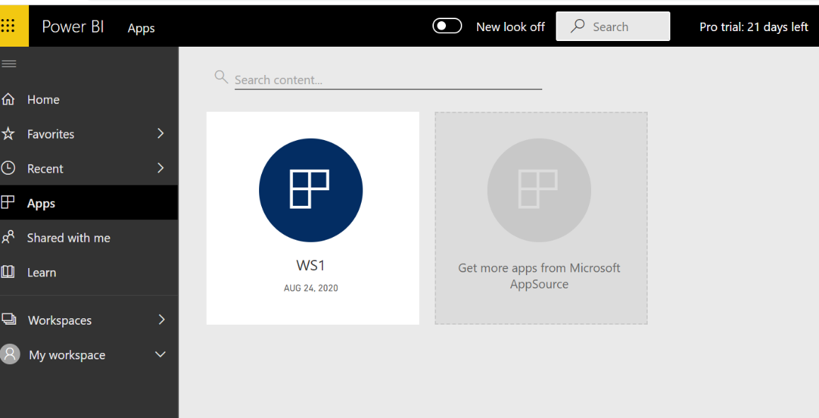

1. **Click on the above icon WS1 and finally Martin is able to see all the 2 Reports and 1 Dashboard!!! See the below screen for confirmation.**

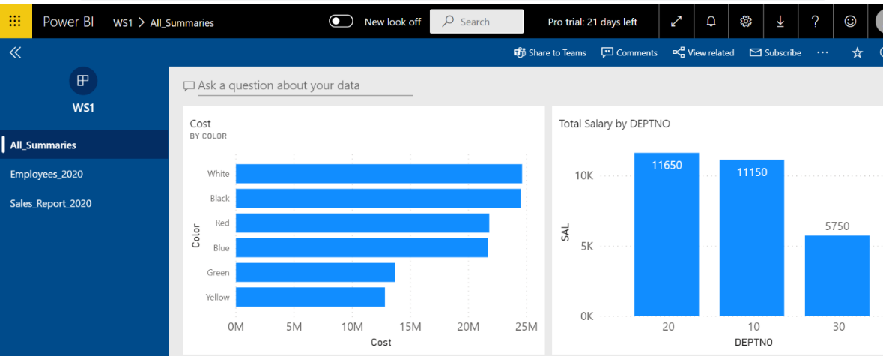

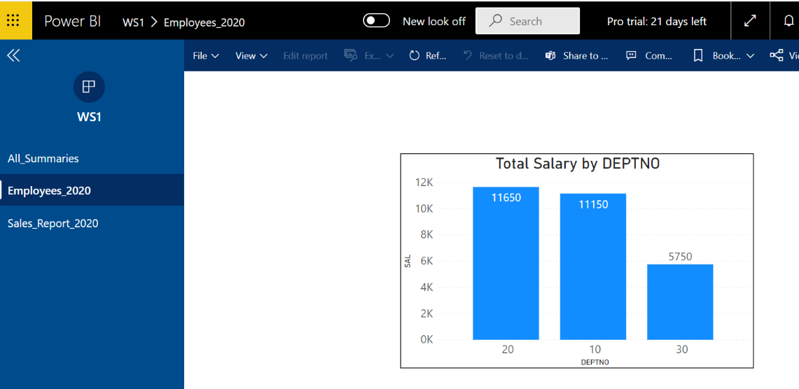

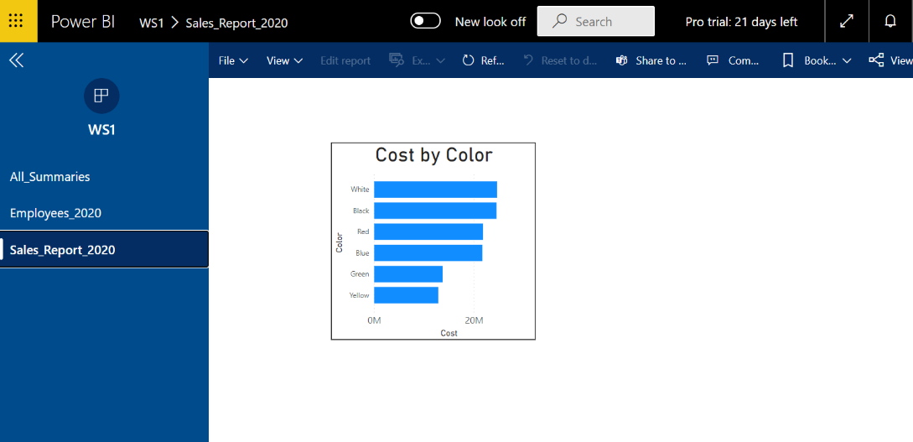

**Changes done in the Reports or Dashboards by the Owner of the Workspace:**

Note 🡪 As per the above use case, if the owner Mandar of the workspace WS1 changes the reports or Dashboards which are in WS1, then by default Martin will not be able to see those changes.

For that to happen, Mandar needs to **update that app** by click on the button **Update app** as shown next 🡪

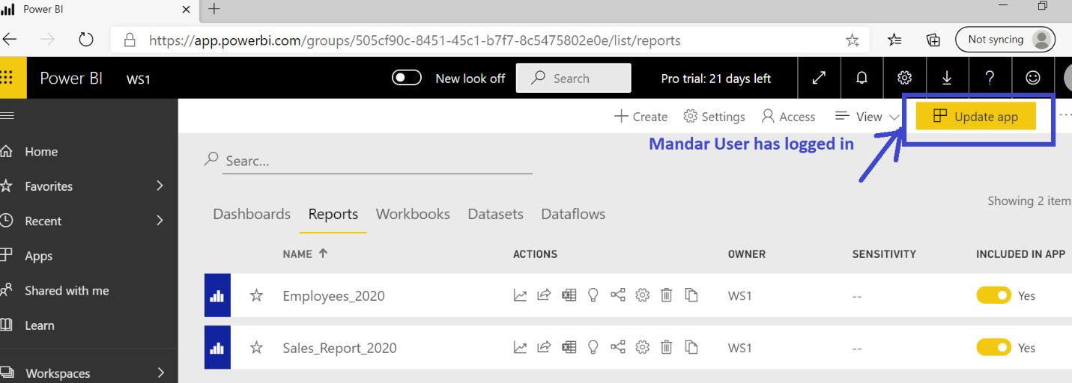

**Allowing other users to Edit Reports and/or Dashboards in the shared Workspace:**

By default, for others users there is **no Edit permission** on the reports and dashboards.

For that, the other users MUST be the **Member** of that Workspace.

So as per this use case if Mandar wants Martin to do changes in the reports and dashboards of WS1 workspace then **Mandar should add Martin as Member of that Workspace**.

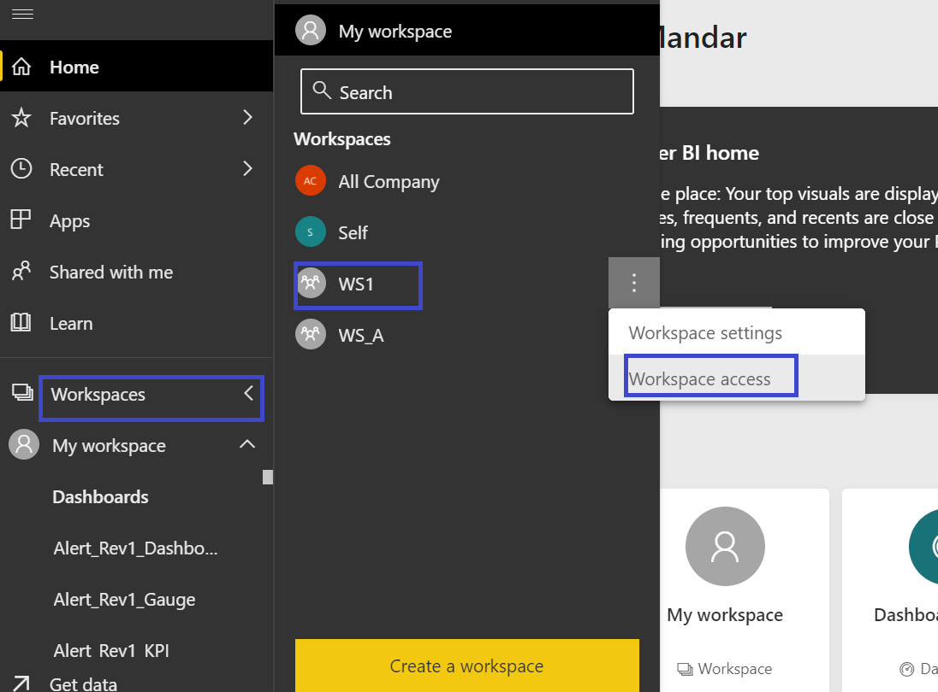

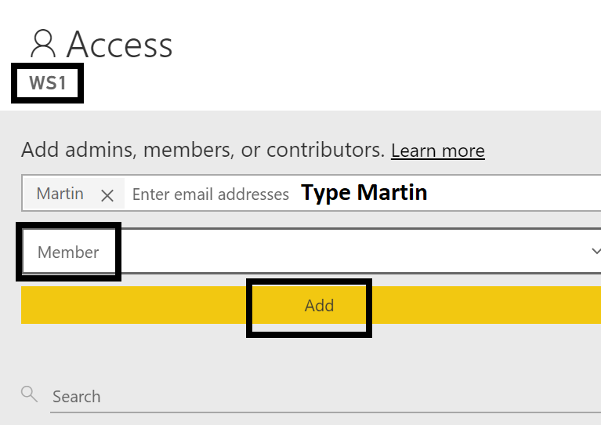

Ensure that **Member** is selected after typing **Martin** in the above screen.

So, finally the Workspace Access window will look as shown below:

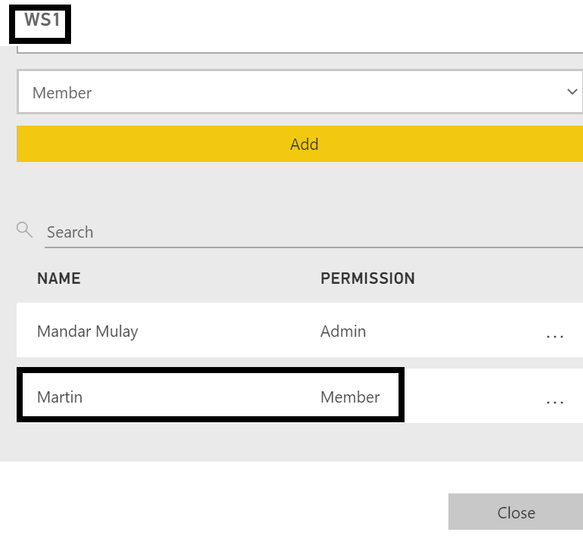

**\*\*\*\*\*Finally, the owner Mandar should NOT forget to Update app. That is important for changes to get finalized. \*\*\*\*\*\*\***

Later, Martin can do the changes in the reports and dashboards of WS1 workspace. Also, once Martin is member, he can download the .pbix file of that report in his local machine!

*******Note 🡪 **Martin should NOT click on App**, **but should click on Workspaces and then select WS1** workspace a shown below:

